Dis-ME-Bactria-Margiana-Afghanistan-one figure

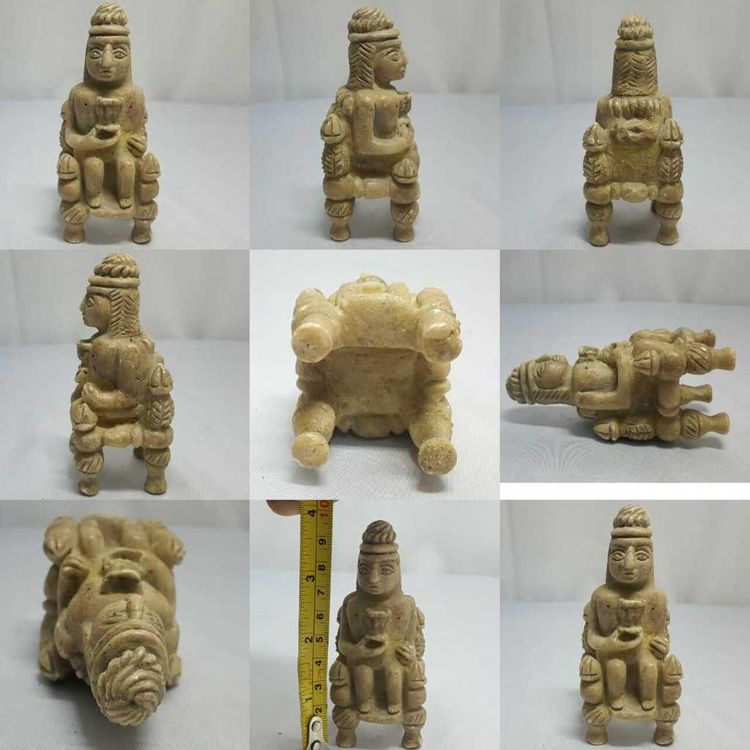

Formal Label: Bactria-Margiana seated male figurine with libation cup in silicified sandstone, Middle to Late Bronze Age, 2000-1650 BCE

Accession Number: GN778.32.A2

Date or Time Horizon: Middle to Late Bronze Age, 2000-1650 BCE

Geographical Area: Afghanistan

Cultural Affiliation: BMAC (Oxus)

Medium: silicified sandstone

Dimensions: H 10, W 7 cm

Weight:

Condition: Excellent

Provenance: [vintage.intaglio](http://www.ebay.com/usr/vintage.intaglio?_trksid=p2047675.l2559), Thailand

**References:**

**Discussion:**